
Submitted by : Spogmai Jan
Roll no : 2430 -0081
Submitted to : sir nouman asim

Computer networks lab
Task 01: Create a network having 4 switches witch are connected through a wire with each other Like Switch 1 connected by wire with switch 2,switch 3 and switch 4, same for other three switches. a) Switch 1 have the Vlan of CS and SE department with 4 pc each vlan. b) Switch 2 have the Vlan of AI and CYB department with 4 pc each vlan. c) Switch 3 have the Vlan of Medical and BBA department with 4 pc each vlan. d) Switch 4 have the Vlan of EE and ADCS department with 4 pc each vlan. You have to develop a network which have following 1. Cs department should have communicate (send mgs) to medical department. 2. AI department should have communicate (send mgs) to EE department.
Switch 01:

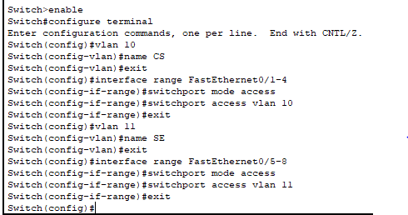

Switch 02:
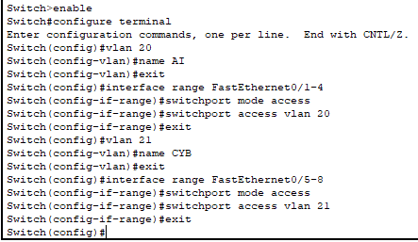
Switch :03
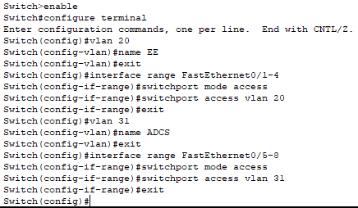
Switch :04
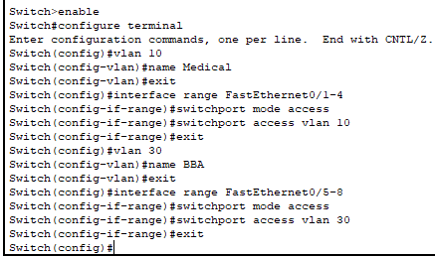

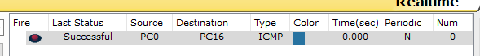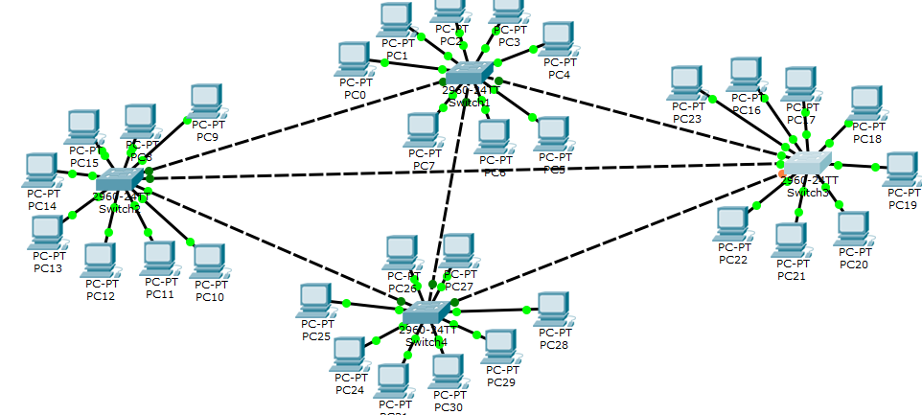
Task 02: Create a network in which you have to use Spanning Tree protocol by using at least 4 switches which are connected through a wire with each other with 2 PC’s. e) Switch 1 have the Vlan of ‘HR’ IP address starts from 192.168.10.1. f) Switch 2 have the Vlan of ‘team Lead’ IP address starts from 192.168.11.1. g) Switch 3 have the Vlan of ‘Employee’ IP address starts from 192.168.12.1. h) Switch 4 have the Vlan of ‘User’ IP address starts from 192.168.13.1. You have to develop a network which have following 3. Team lead department should have communicate (send mgs) to Account department network. 4. HR department should have communicate (send mgs) to Employee network.
Switch 1
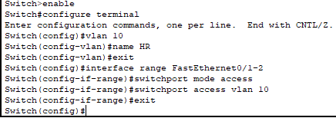
Switch 2
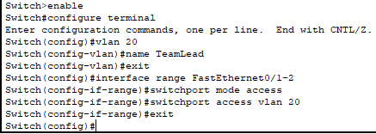
Switch 3
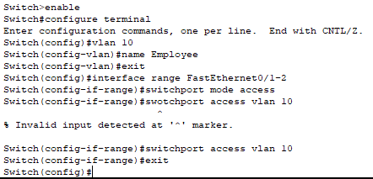
Switch 4
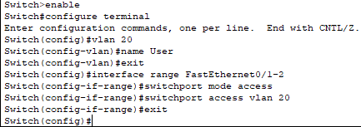
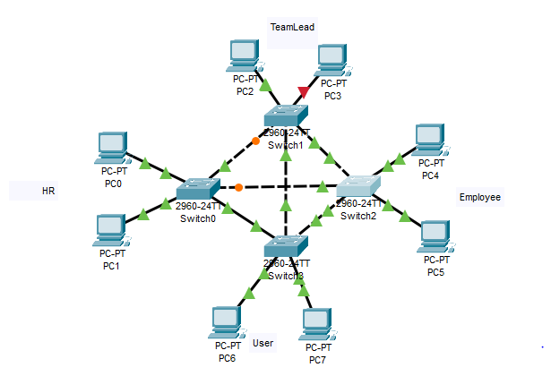
Task 03:
Make a network having 9 pc. Use three switches and 1 router for communication sent message from Pc3 t0 Pc6. Establish the connection between the systems by sending msg.
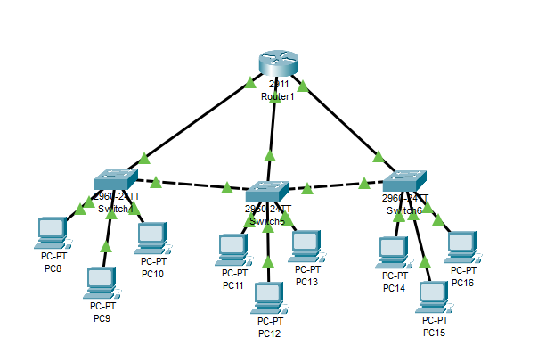
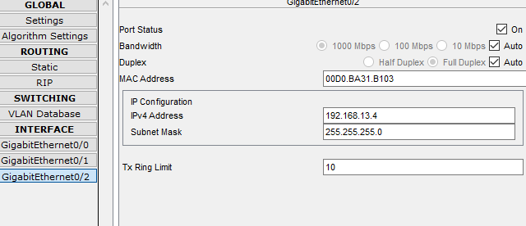

Task 04: Create a network having 2 switches which are connected through a wire with each other. Then each switch connected with router. • Switch 1 have two Vlan’s 10 and 20. • Switch 2 have two Vlan’s 30 and 30. Configure the network and establish the connection between them.




